- Coordinator Name |  | - Coordinator Email
- School Name |  | - Coordinator Mobile

  - What is the Objective(s) OF the YEARBOOK?
Write most important objective first, e.g., a keepsake for the student
  - Does the yearbook need to include any Particular design Elements?
If yes, please state and specify what colours, fonts etc., where applicable
Logo:
Motto:
Fonts:
Colours:
  - Describe the ‘Feel’ of the yearbook?
For example, fun, modern, traditional, playful, vibrant, minimal, etc.
  - Were there any Particular likes/dislikes from your previous yearbook or yearbooks you have seen?
E.g. I liked the background graphics on page 24. Please also supply relevant pages

  - Which of the following photos do you like/Dislike?
Please specific like or dislike under each photo and why/why not

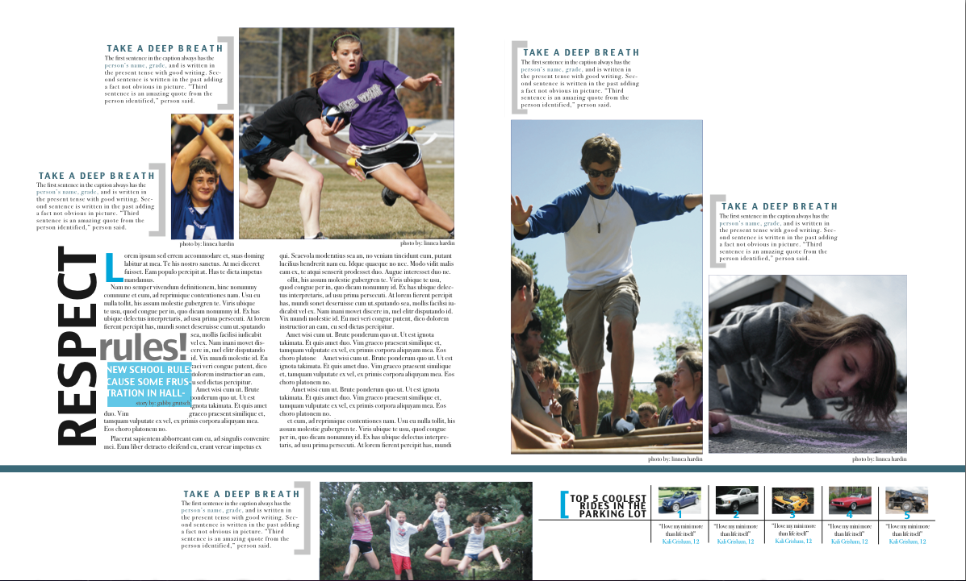 | 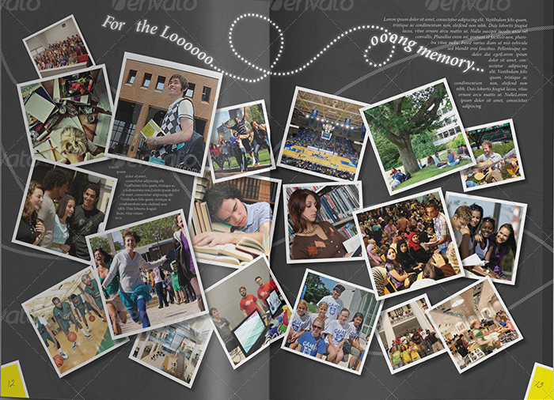
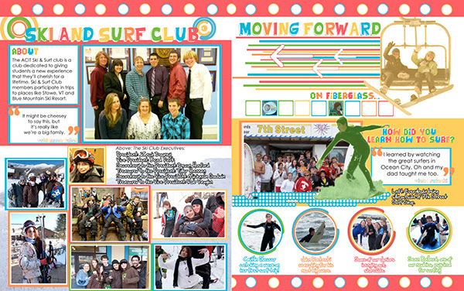 | 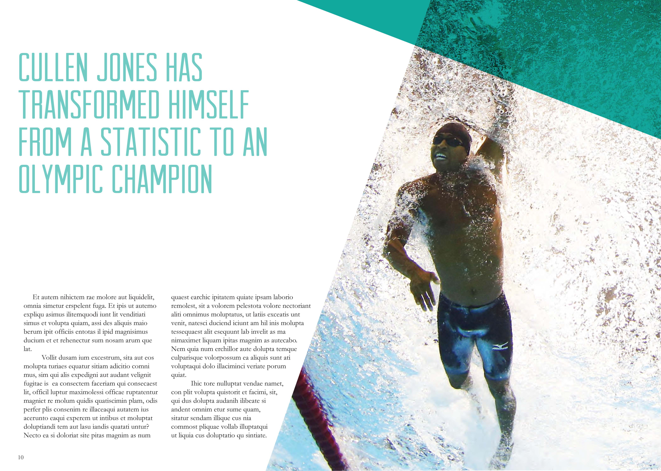
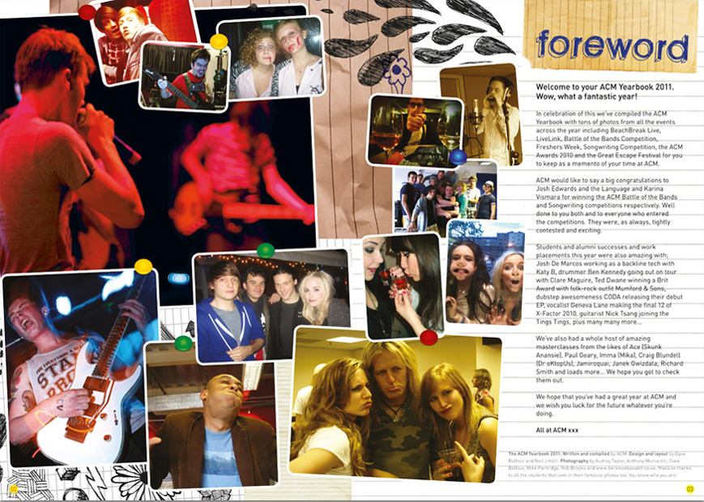 | 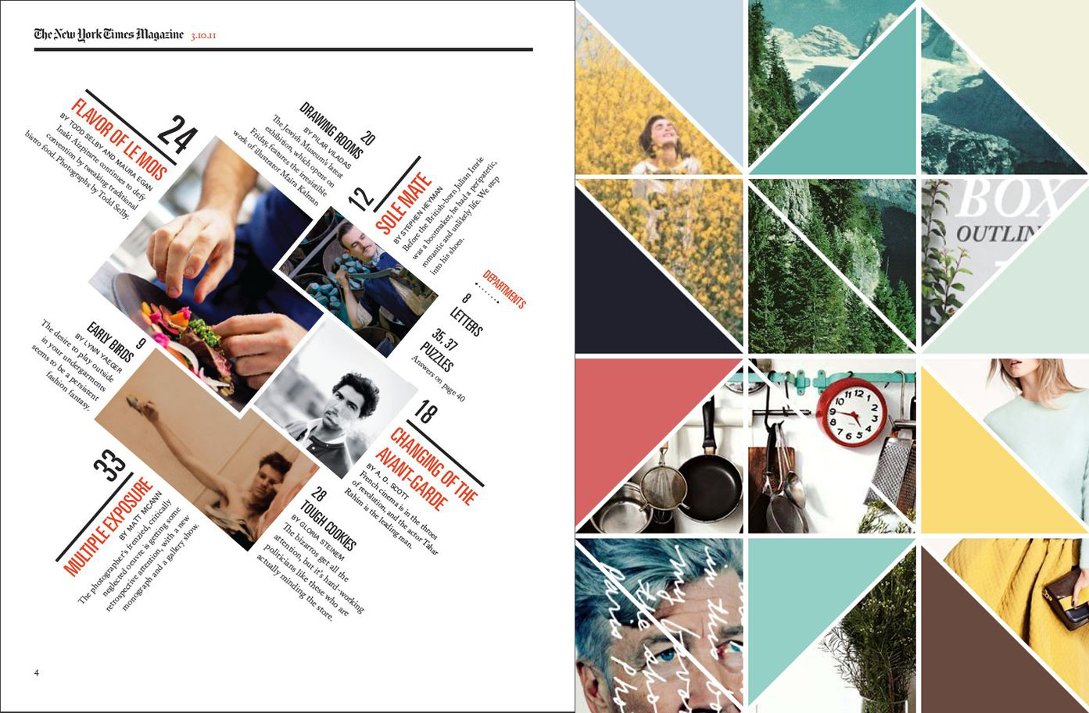
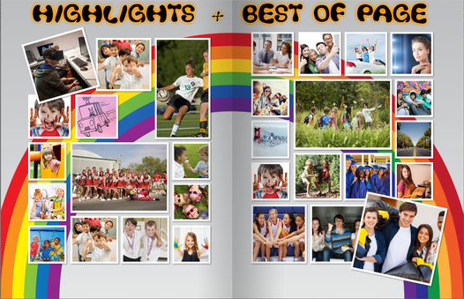 | 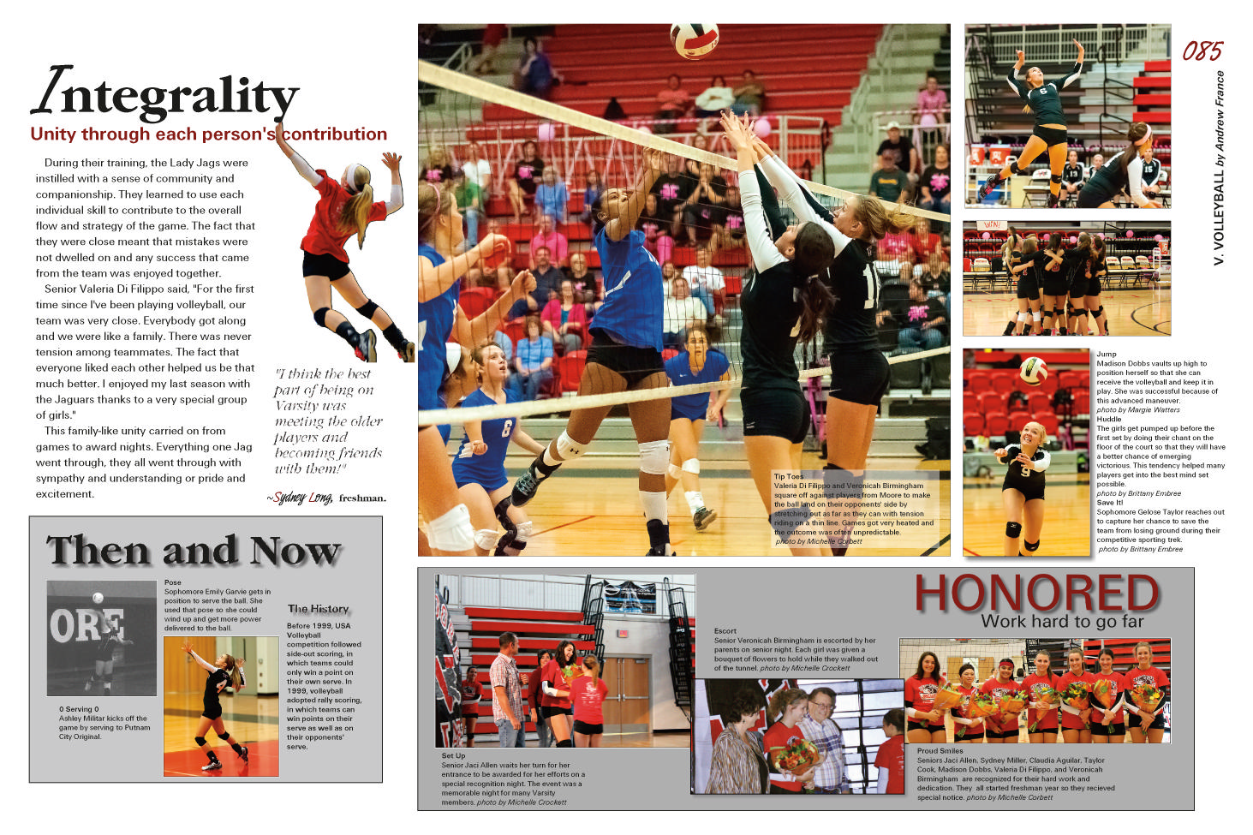
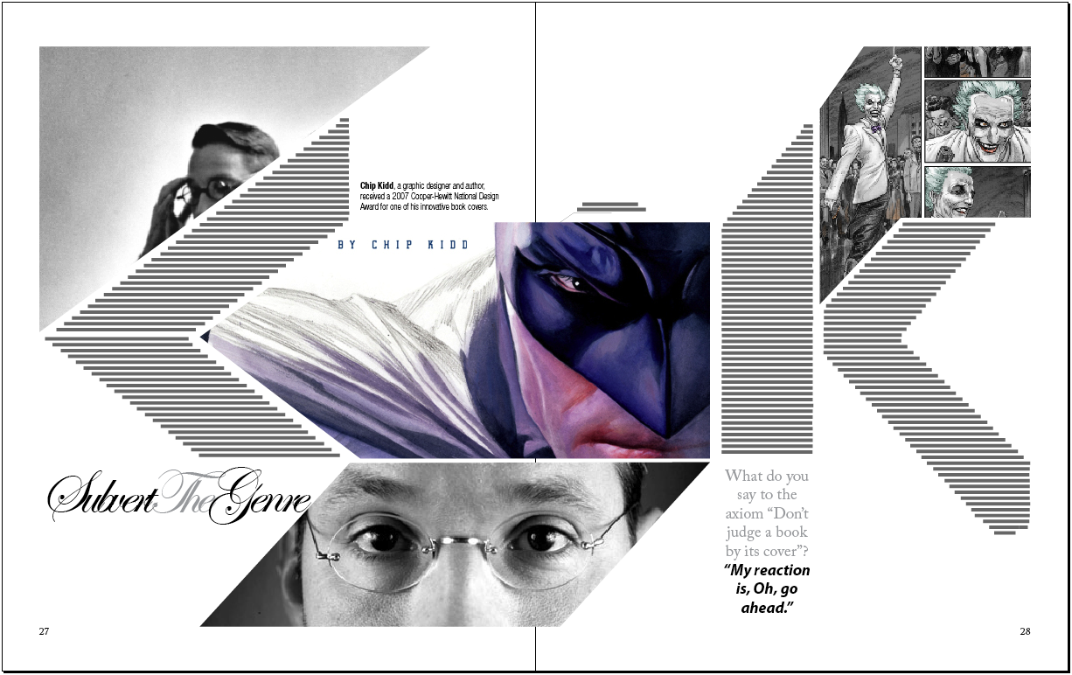 | 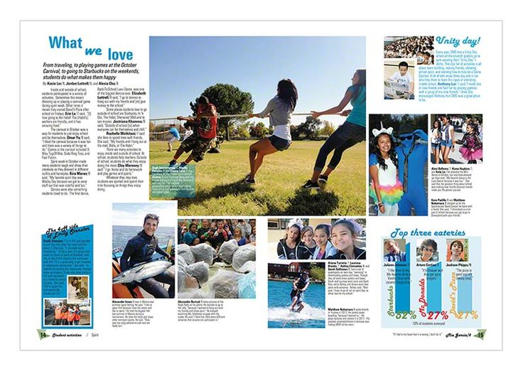
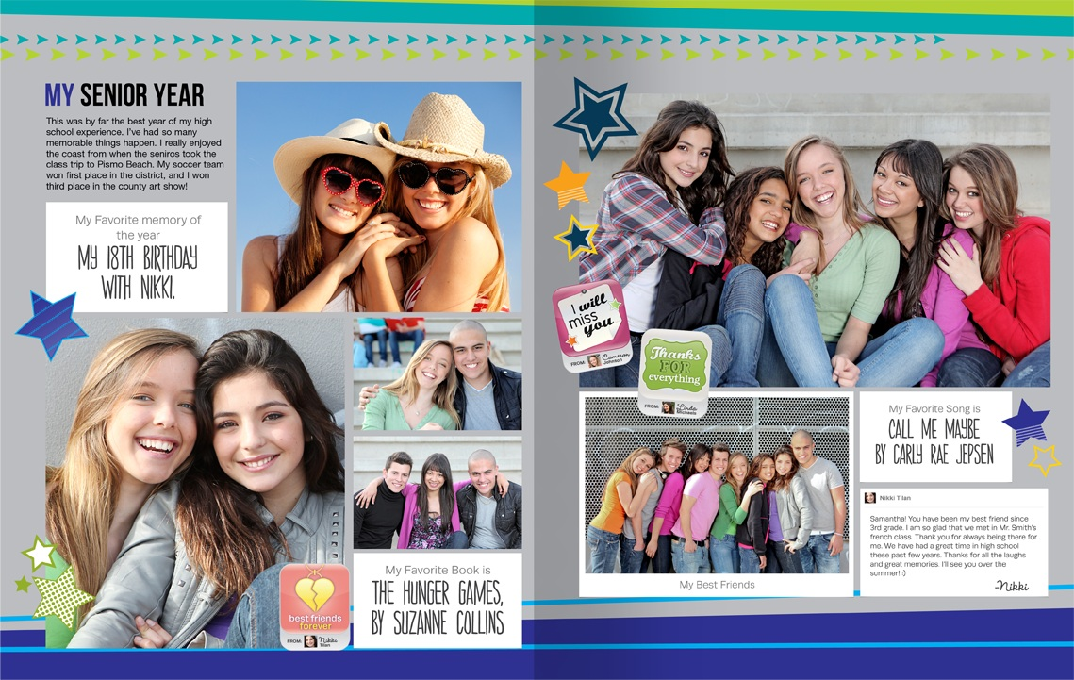 | 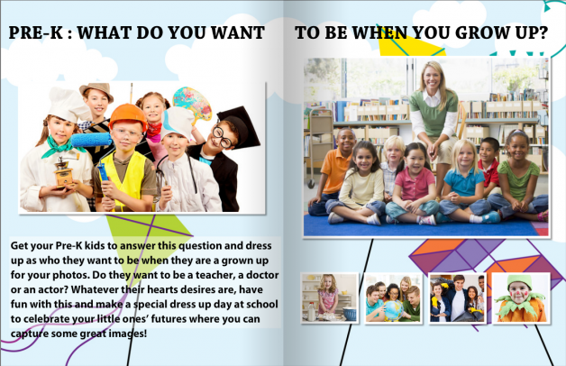
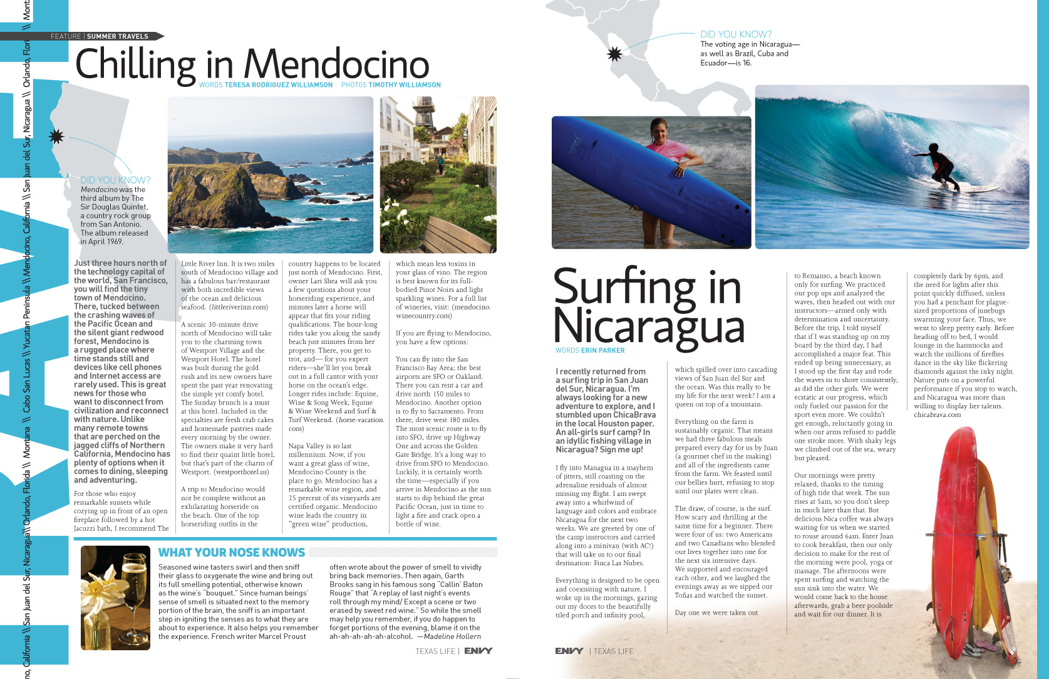 | 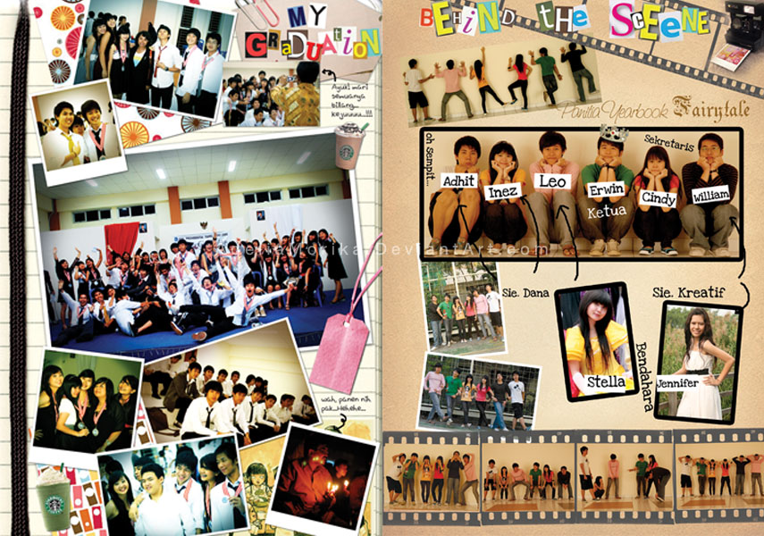
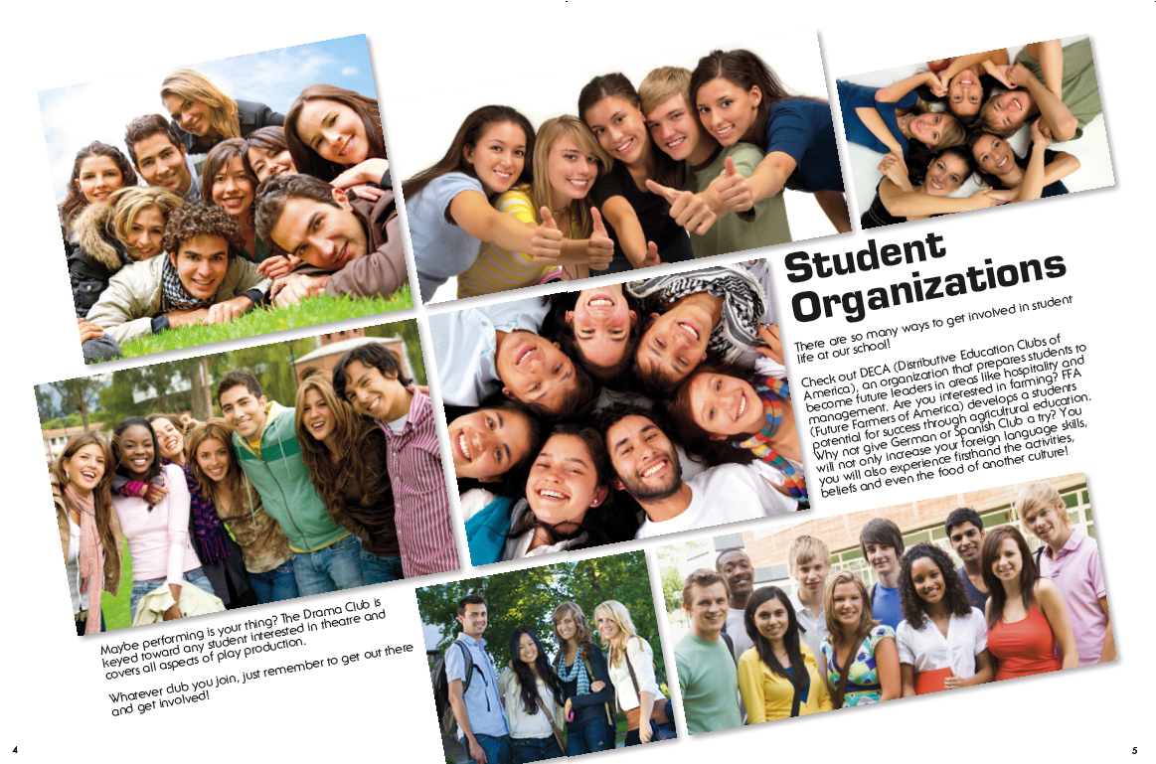 | 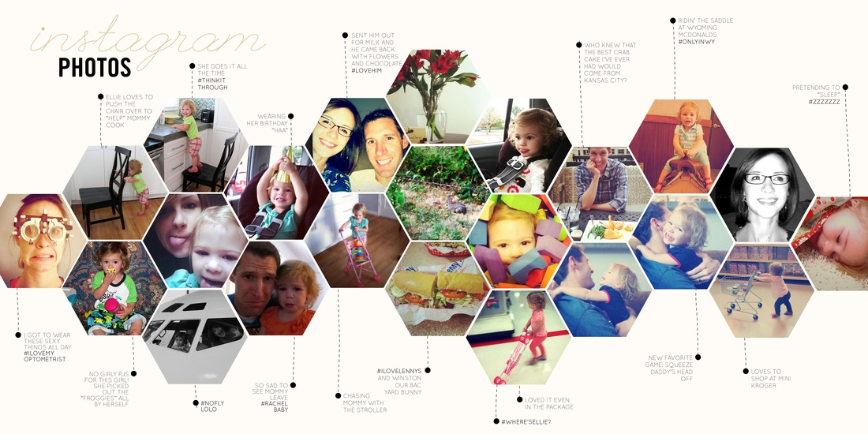

  - Which of the following Colours do you like/Dislike?
Please specific like or dislike under each colour combination and why/why not

  - Which of the following fonts do you like/Dislike?
Please specific like or dislike under each font and why/why not

